Znakovas, Dominic
centre number: | Candidate number:
RALLY PACE NOTE MAKER
COmputer science nea

Table of Contents
What are pace notes? 1
Analysis 1
Problem 1
Who is this for? 2
Background 2
Research 3
Map Data Source 3
Corner Radius Calculation 3
Distance Between Nodes 4
Corner Direction 4
Route geometry 4
Routing Engine 5
Modelling of the problem that will inform the design stage 6
Limitations 8
Conversation with a 3rd party 8
Objectives 10
Documented Design 12
References 13

What are pace notes?
“A method of accurately describing a rallying route to be driven in extreme detail”
-Wikipedia

Analysis

Problem
Currently, nothing public exists that will turn real roads from map data into pace notes used by rally co-drivers. I will make a program that will turn a user-inputted map route into a rally stage with accurate pace notes.

Who is this for?
The end user of this software will be someone who likes rally, has a car, and wants to have a rally experience with friends without having to spend time learning how to write pace notes. This is something I personally have had trouble with in rally simulators with my friends, where we will struggle to know the severity of a corner while driving slowly through it as it will feel tighter when driving faster. The creation of pace notes in high level rally championships such as WRC is an art that is hard to master and that getting wrong can lead to the driver misjudging a corner, so I aim to make this easier for people without years of experience doing such.

Background

Terminology
Stage - A route which is raced in a time trial
Rally - A group of stages make up a rally, also the name of the sport
Pace note - Information about the corner to come read by a Co-Driver sat beside the Driver
Recce - The process of driving slowly through the stages to gather data for the pace notes and condition of the stages.

How my pace notes work:
The pace notes I will be using in my software will be a mix of pace note styles from many different rally simulators that I have experience in, including EA Sports WRC, Assetto Corsa Rally, DiRT Rally 2.0, and other rally racing titles.
An example of a pace note is “6 Right” (written in my software a 6R which has 2 parts to it, the corner severity and the direction. The direction is self-explanatory, however the corner severity needs to be explained. corners go from 1 to 6, with 1 being a tight corner and 6 being wide corner. There are also some other terms that will be used to describe corner severity, being hairpin (HP) which is a very tight corner which may even require the use of the hand break, square (SQ) which is intuitively a corner that is roughly 90°.
From widest to tightest: 6, 5, 4, 3, SQ, 2, 1, HP
You will also come across a number, such as 70, being said after a corner. This refers to a 70 meter straight section before you reach another corner.
You may also come across a call that a corner is “long” or “short” this means that the length of road that is a corner is either unusually long or unusually short, which will affect the speed at which you enter the corner, and how much you must turn to make the corner.
Another thing you may also come across is a call such as “tightens” or “widens” which will be indicated by a T or a W respectively, this means that the corner’s severity changes which is more common with longer corners that have space to noticeably get tighter or wider. Typically if a corner widens then you can get back on the throttle much earlier than you normally would meaning you gain more time.
Since OSM doesn’t have good data on elevation, and is working off map data, other calls such as blind, crest, bad camber, caution, cut will not be able to be implemented

Research
My research methods include internet searches, examination of existing tools, and analysis of open source code

Map Data Source
I researched this by first seeing if google maps had an API that I could use to gather data from roads, however this was locked behind a paid API key (whilst technically you do get $200 of free credit for the API, I don’t want to have a possibility of running out of google maps credit while developing the program) so I looked on Youtube and found a video (referenced) that explains how to use this API called overpass finding the location of all the airports in Papa New Guinea. While specifically is not useful to me, after further research into the overpass API from a page called the OpenStreetMap wiki I discovered that it is based on another website called OpenStreetMap (OSM) that has a complete map of earth with map notes, data, and public GPS traces for almost every road including small back roads which, after looking at the map data of these roads, have sufficient detail to create pace notes from. The Overpass API wiki has information on how to take a section of road and turn it into data about the latitude and longitude of each node along that road in the form of Java code which I can read and use to help with my own coding.

Corner Radius Calculation
I thought that you would be able to find the tightness of a corner by drawing a circle connecting the nodes of the corner and calculate the radius of the corner and use that as a measure of how tight the corner is with a smaller radius meaning a tighter corner. I then researched if there was anything already made for OSM that did this and I found a page to a road curvature finder called Curvature that was originally made to help motorcyclists plan trips that have a lot of fun corners, and after looking further into this I found a video explaining how Curvature finds the curvature of a piece of road and it was very similar to my method of drawing a circle with the nodes on the radius, but instead of trying to make the whole corner fit on 1 circle which would be practically impossible due to real life roads not being perfect circles, Curvature draws a triangle connecting 3 consecutive nodes and draws a circle with the hypotenuse of the triangle being perpendicular to the radius of the circle drawn and calculating the radius of the aforementioned circle. This is then repeated for all nodes, incrementing the end node of the triangle by one each time to find the radii of each segment of the road. Curvature’s algorithm diverges from my needs here as it takes an average of the curvature of the entire road and calculates a score based on that, however I was able to find some useful information I the source code attached by the creator of Curvature that explains how they find the radius of a circumcircle. The python code uses an equation that was referenced to a Math Open Reference page that has information circumcircles and an equation on how to find their radius.

Distance Between Nodes
Another important thing for me to do is to find the distance between 2 nodes, this is not only a key part of finding the radius of the circumcircle but is also useful in finding the length of a straight section of road. Looking into the source code of Curvature further, I found a link to a page that says how to compute the distance between 2 locations of Earth from coordinates. After a reverse google search, I have found that the code in that page is a simplified python implementation of the Haversine formula 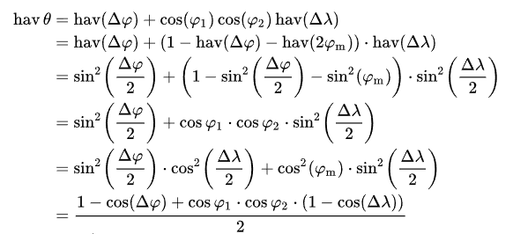. This, however, is long and contains many math functions which is not good for optimisation as while looking at another project that deals with a similar problem, which is linked in the section below, I saw that they use a much simpler solution to calculate the distance between 2 nodes using an equirectangular projection of Earth instead. This works by converting the longitude and latitude into meters using cosine to account for the fact that on the equirectangular projection, the lines of longitude converge towards the poles, and using Pythagoras on the resulting flat coordinates. This is easier to implement than the Haversine formula, and the difference between using the Haversine formula and the equirectangular projection method across short distances is almost imperceivable which makes it the better choice in this implementation.

Corner Direction
Another thing I need to calculate is the direction that the road turns, and after some googling I found a pace note generator demo’s source code that used vectors to calculate the direction by doing the 2D cross product of the 2 vectors, if the result of this is positive the road turns left and if its negative the road turns right. After testing out this in code, I realised that the cross product formula takes distance between nodes into account, so I needed to find another option that would find the angle irrespective of the distance between them. That’s when I found the atan2 function in C#. Atan2 works the same as arctan, that gives you the angle of a right triangle if you have the height and length. We can think of coordinates as right triangles, so we can use arctan to find the angle. However, arctan has 2 big flaws. If the road goes straight up or down, you will get a division by 0 error which will crash the code. It’s also impossible to tell which way the road goes as 2 negatives cancel, so 45 degrees could either be up and right or down and left. This is where atan2 comes in. It takes both y and x as separate arguments and then carries out the arctan. This means that the function knows the signs of y and x, so you get back the actual heading of the coordinates.

Route geometry
After attempting to start the Documented Design stage, I realised that I the overpass API will only give me the coordinates of nodes in a boundary box, or preset length of road called a way, with no way to create a custom route and get all the nodes for that route. So, after posting a question about this to the OSM forum
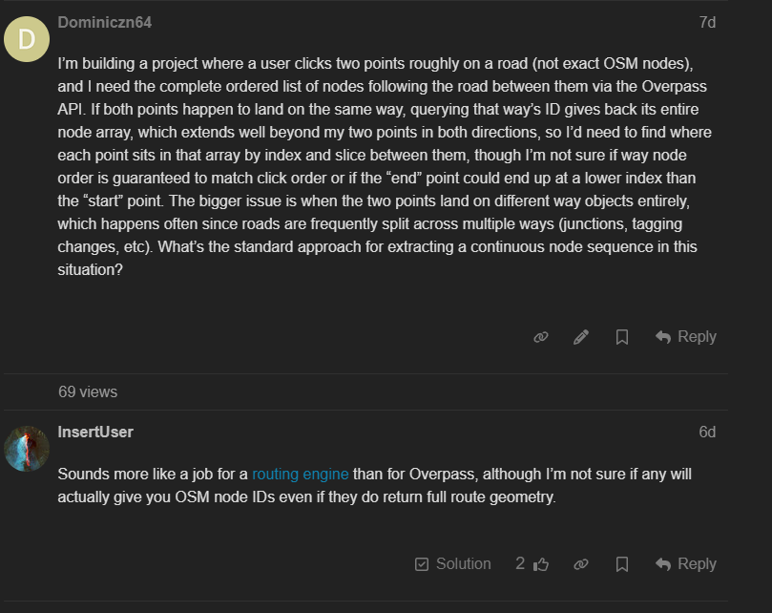
I have learned that I need to use a different OSM based API called Open Source Routing Machine (OSRM) and after reading the OSRM HTTP API documentation I learned that I can request the geojson of the OSRM route which gives me a json response containing the coordinates of all the nodes in order from the start to the end of the route. This is highly beneficial as it means that I only need one API call to get all the coordinates of points on the route as opposed to having to do API calls for each point of the route, of which could be hundreds of nodes. OSRM also automatically picks the nearest node that is on a road, so if a user picks their start point on, for example, a field, the first node I get back in the response will be on a road

Routing Engine
Not only do I need a routing engine, but I also need a way for the user to enter the route from my software. After searching up how I could do this in WPF, which is the framework I will be using to make my GUI, the top options were Bing maps, which requires a paid API key similar to how google maps does, and Gmap.NET which is an open source software that lets the user to interact with maps from many different map providers including Google, Yahoo, Bing etc. When the user enters a route, I will be able to get the coordinates of the start point, end point, and any waypoints in between which I can put into the OSRM query to get the coordinates of all the nodes along that route.

Modelling of the problem that will inform the design stage

Getting the nodes from a route
The user will enter a route in Gmap in my software, which will give me the coordinates of the start point, end point, and all checkpoints in between which I can pass into an OSRM query to get a geojson as a response which will contain an ordered list of all coordinates of all the nodes along that route.

Calculating the sharpness of a corner
With any 3 nodes:
- Draw a line between all the nodes to form a triangle where 2 sides are road segments and the line between the 1st and 3rd nodes is the third side of the triangle. (theoretical) 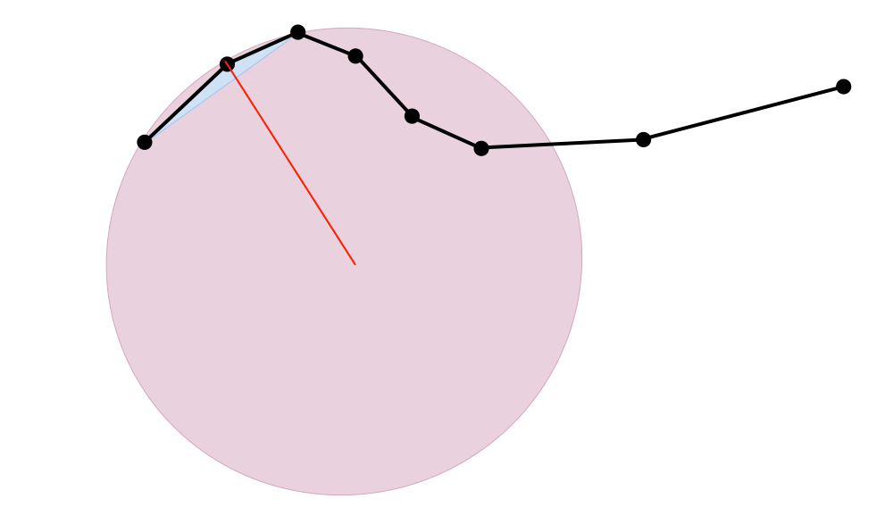
Figure 1. Circumcircle visualisation from Curvature
- Calculate the distances of all these lines using the equirectangular projection method of calculating the change in horizontal distance with
$$x=R×cos{(avgLat)}×∆lon$$
and the change in vertical distance with
$$y=R×∆lat$$
where R is the radius of the mean earth in meters (6371009m), avgLat is the average of the latitude coordinates, converted to radians since coding languages use radians
$$avgLat=\frac{{lat}_{1}+{lat}_{2}}{2}$$
and Δlon and Δlat are the difference between the longitude and latitudes converted to radians. The actual distance between nodes is then found by doing Pythagoras on the x and y components
- Calculate the radius of the circumcircle using the formula:
$$r= \frac{abc}{\sqrt{(a+b+c)(b+c-a)(c+a-b)((a+b-c)}}$$
Figure 2. Equation for radius of circumcircle
- Use a sorted dictionary containing the maximum radii of each severity level to look up and turn each radius into a corner sharpness

Calculating which way a corner turns
With any 3 nodes A,B, C and all coordinates in radians:
- Calculate the horizontal component of vector AB with
$${\vec{AB}}_{x}= R ×\cos{({avgLat}_{\overset{→}{AB}})} ×{Δlon}_{\overset{→}{AB}}$$
and the vertical component of vector AB with
$${\vec{AB}}_{y}=R×{∆lat}_{\vec{AB}}$$
- Calculate the horizontal and vertical components of vector BC with the same equations used above, where AB is BC
- Calculate the cross product , setting the Z value to 0 since we are working on a 2D plane with no elevation data with
$$D=\left({\vec{AB}}_{x}×{\vec{BC}}_{y}\right)-\left({\vec{BC}}_{x}×{\vec{AB}}_{y}\right)$$
and if D > 0, then the corner turns left, if D < 0, then the corner turns right

Detecting where a corner is
I’ll start this with an example.
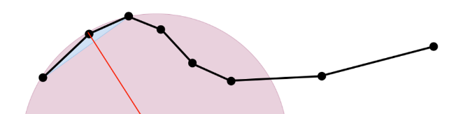
Looking at this string of nodes, taken from the above image describing how to calculate the sharpness of a corner, I can tell that if you were to make pace notes for this road, they would most likely be 6R T 3 into 5L W, but how would the computer know where the 6R starts, and how would it know that it tightens to a 3, and then goes into a 5L and that it widens? I think it’s obvious that we can detect a corner going from 3R to 5L purely based on the change in direction, but what about the actual corner being detected in the first place? Since every set of 3 consecutive nodes produces a circumcircle radius, the algorithm produces a continuous stream of radius values rather than discrete corners. To group these into corners I will use the sign of the 2D cross product that I found in corner direction algorithm. While the result remains consistently positive, or negative (left or right respectively), the nodes are grouped into a single corner and stored into their own list. When the sign flips, the direction has changed and the current corner ends.

Detecting where a straight is
A straight is detected when the cross product stays close to 0 across consecutive nodes for a minimum distance. The total length of all the nodes are recorded for the distance call.

Detecting whether a corner tightens or widens
- Calculate 2 separate circumcircles, one with its points being the first node, a node ¼ the way in, and the middle node, and the other with its first node being the middle node, a node ¾ the way in, and the last node
- If the radius of the exit circumcircle is a above or below a certain amount (e.g 1.5x the entry radius) then the corner widens or tightens
This only works on longer corners that have a certain number of nodes, this is fine since its only longer corners that do noticeably widen or tighten

Limitations

There will be no elevation data. This is due to a multitude of reasons, such as OSM not storing elevation data so I would have to use another API to get elevation data, which would require a second API request which is not efficient, additionally detecting whether a road is a crest, blind, or is a jump will be algorithmically difficult as I will need to figure out the steepness of the road and whether it is steep enough that visibility over the top is compromised. This also depends on the car the user is driving since a small sports car will have significant worse visibility than a dedicated rally car, which are typically raised to have better suspension, which improves visibility over crests. Knowing if a crest is a jump will also depend heavily on the driver’s speed as they go over the jump.
Another limitation will be knowing if a corner is blind since OSM doesn’t give me data on things such as fences, trees, houses, etc that may block someone’s vision of the road

Conversation with a 3rd party
I hosted an interview with my 3rd party, first asking questions to see his current level of knowledge about rally pace notes, then asking questions about what he would want to see from my project. The following is what he has inspired me to do:
- Include the severity and direction of each corner in the pace notes so the user knows where the corner goes, and how much to turn / how fast to go for that corner
- I will include the next 2 and previous 2 pace notes on the screen (including the current pace note) so the user can see what is coming ahead, and can repeat calls if they driver requests it
- I will include a stage timer, where the user can press a button (such as space) to start and stop the timer
- To save split times, between the start and stop time the user can press a button like enter that is easy to press
- The previous stages that are created by the user will be saved for if they want to drive that stage again
- A hazard reporting tool will be implemented that will allow users to mark a specific pace note as having a hazard and will allow them to go back after the stage to add a short description of the hazard, which will be displayed to the user during the next run of the stage

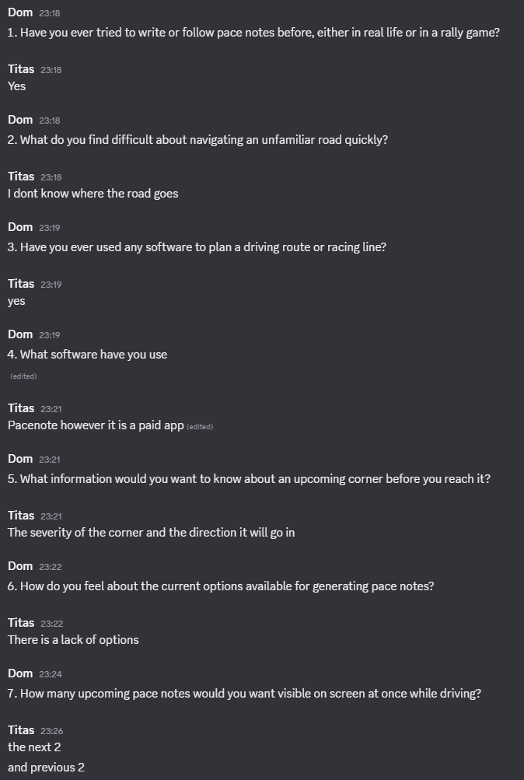
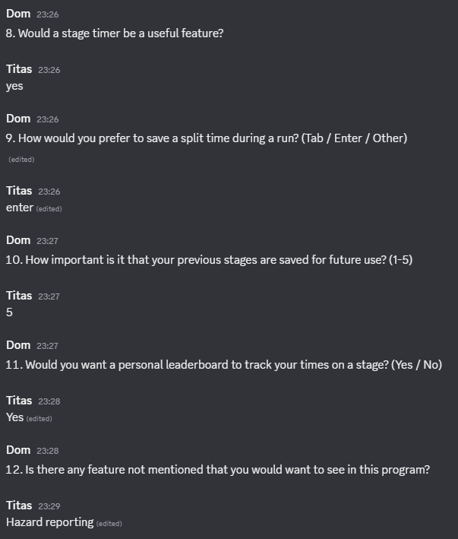

Objectives
- The application will be built using WPF (Windows Presentation Foundation) to make the GUI
- The pace note making algorithm should sort corner tightness into the following levels ranging from sharpest to widest: HP, 1, 2, SQ, 3, 4, 5, 6 determined by a sorted dictionary of maximum radius thresholds that will be calculated during the creation of the software
- The sharpness of a corner should be determined by the radius of the circumcircle connecting 3 OSM nodes
- The pace note making algorithm should determine the direction of each corner, being left or right (L or R respectively) by calculating the 2D cross product of the vectors of 3 nodes
- The pace note making algorithm should determine if the corner widens or tightens by comparing the circumcircle radius at the entry node vs at the exit node of the corner and adding “widens” or “tightens” (W and T respectively) to the pace notes
- The opening screen should present the user with buttons to either create new pace notes from a map, or open previously saved pace notes, named “Create new” and “Open” respectively
- The previously saved pace notes should be saved locally as a JSON in the user’s local appdata file
- If the user chooses to open previously saved pace notes, they should be presented with a list of their pace note files, with the option to open the map view of each one that shows its route to see where it is
- If the user chooses to create new pace notes they should be presented with an interactive map where they can mark the start point, their path on the road, and the end point of their route, snapping each point to the nearest OSM node
- The user’s path should be saved to a queue so the user can press ctrl+z to easily undo mistakes and ctrl+shift+z to redo their actions
- The pace notes should be saved in real time after the user does an action so that if they accidentally close the program, their progress is saved
- The user should be able to preview the pace notes next to the route map in a split screen view before confirming to continue
- When in the main screen to view pace notes, the user should be able to press space to start the stage timer and space again to stop the timer
- When the timer is running, the user should be able to press enter to save a split time
- The pace notes should be in a queue such that the user can press the arrow keys to cycle through them
- The next 2 and previous 2 pace notes should be visible on the screen along with the current pace note as requested by my 3rd party
- If the user presses backspace a hazard should be recorded at that pace note, that after the stage the user can label with a description of the hazard at that point on the stage as requested by my 3rd party
- At the start, a flag icon should be displayed with the next few pace notes already loaded so the user can see what is coming up
- At the end, another flag icon should be displayed with empty spaces after it so the user can’t cycle past it
- The user should be prompted by a dialogue box to save their stage time to their personal leaderboard after they finish the stage

Documented Design

High-level Project Breakdown
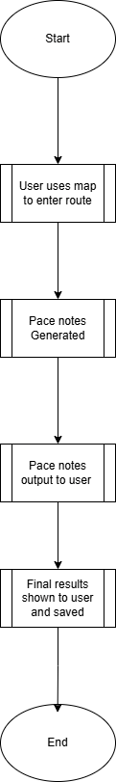
Here is a high-level overview of my project, this is to give me a general shape of how my project will work. Obviously, each process will be complex, so this seemingly simple flowchart will result in a much more complex project in practice.

Each process here is just a general overview of what I want the program to do running in real time, going from user entering a route to showing the user their end time

UML Class Diagram
Below is a UML class diagram that outlines all the classes I will need to make my project, from the UI to the maths happening in the background. It helped me set out a structure for how I will code my project, so I don’t get sidetracked, and know where to start as starting to code a project as big as this is daunting without a clear structure to follow.
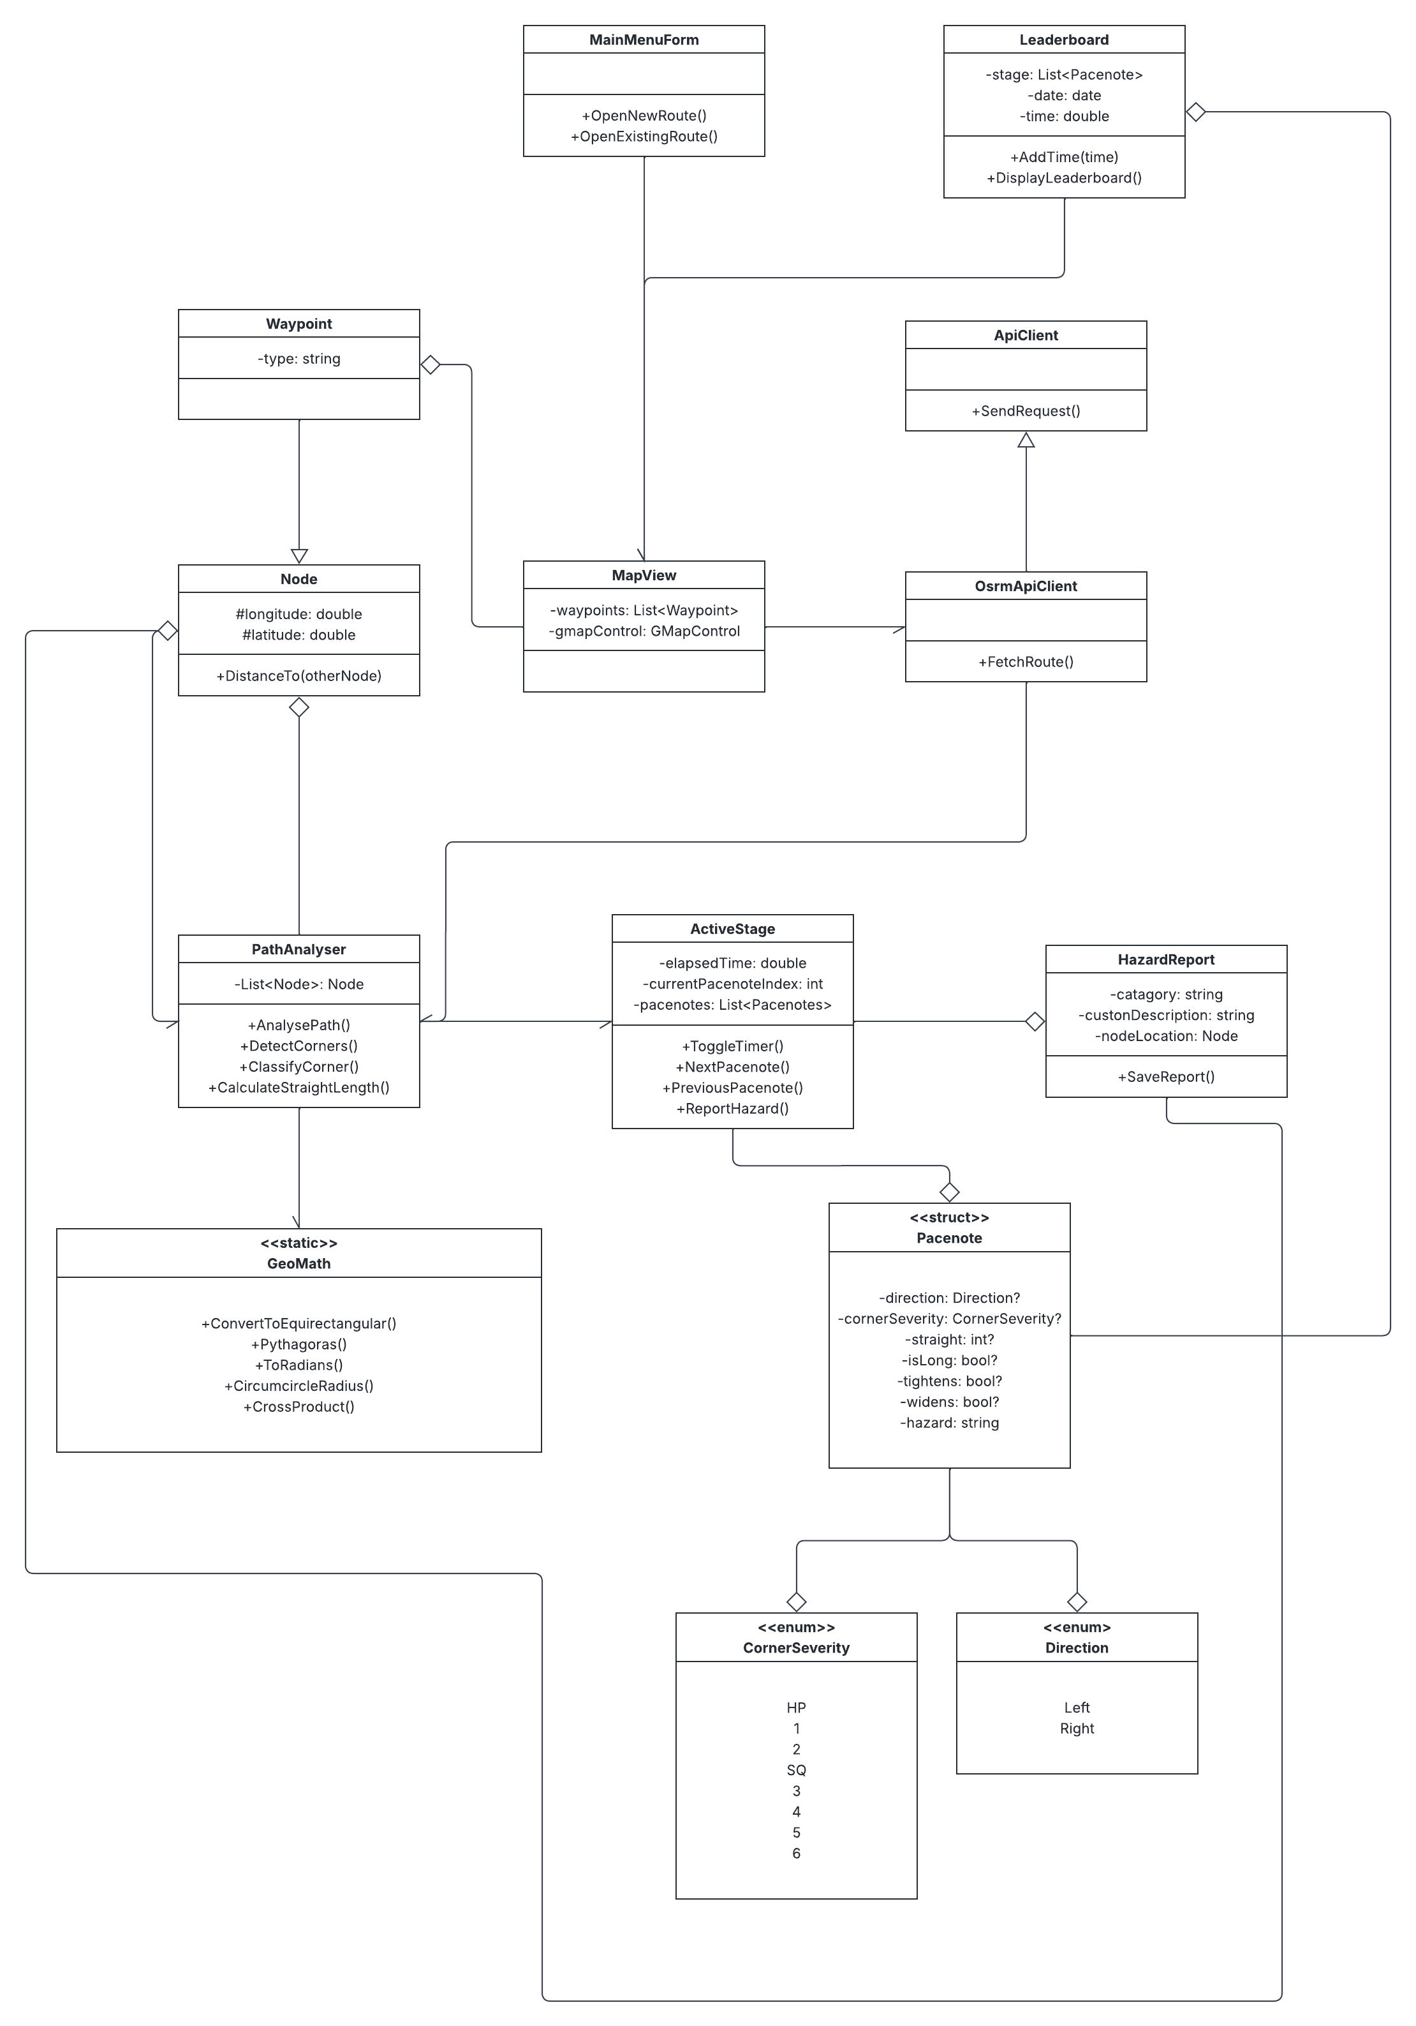

UI Design
I have made a mock-up of what I want my UI to look like in photoshop. This helped me think of the features I want to include, and how I want to lay it out.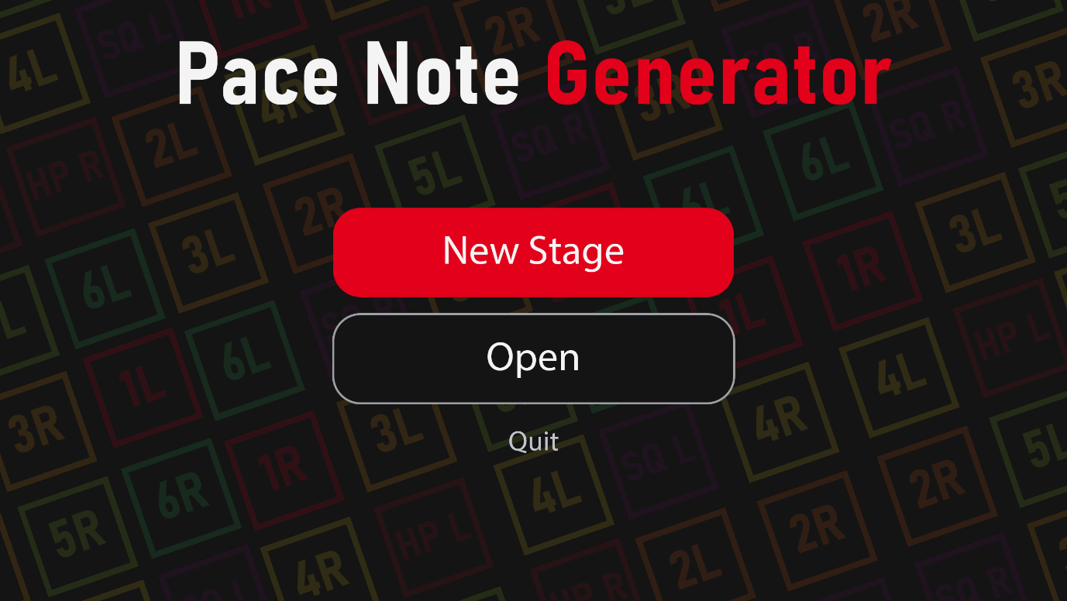
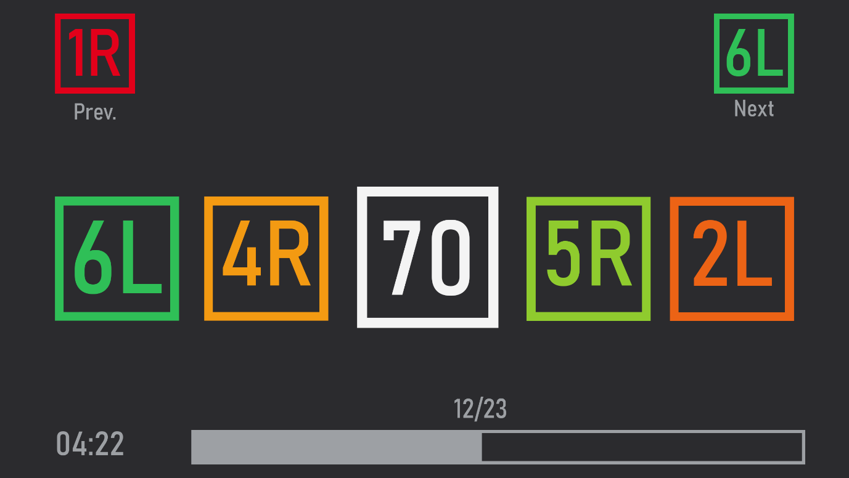

References
Adam (2020). Curvature. [online] Curvature. Available at: https://roadcurvature.com/.
Consequential Coding (2024). How to use Overpass API. [online] YouTube. Available at: https://www.youtube.com/watch?v=M_1Sas9l57o [Accessed 19 June 2026].
Cook, J. (2026). Python code for computing the distance between two (longitude, latitude) pairs. [online] Johndcook.com. Available at: https://www.johndcook.com/python_longitude_latitude.html [Accessed 19 June 2026].
Olbricht, R. (2022). Overpass API - OpenStreetMap Wiki. [online] Openstreetmap.org. Available at: http://wiki.openstreetmap.org/wiki/Overpass_API [Accessed 19 June 2026].
OLD_Anonymous (2018). Calculating heading direction for vectors. [online] UnKnoWnCheaTs. Available at: https://www.unknowncheats.me/forum/c-and-c-/304670-calculating-heading-direction-vectors.html [Accessed 25 Aug. 2026].
OpenStreetMap (2024). OpenStreetMap. [online] OpenStreetMap. Available at: https://www.openstreetmap.org/.
Page, J. (2011). Circumcircle of a Triangle - Math Open Reference. [online] www.mathopenref.com. Available at: https://www.mathopenref.com/trianglecircumcircle.html.
Project OSRM (2026). OSRM API Documentation. [online] Project-osrm.org. Available at: https://project-osrm.org/docs/v5.5.1/api/?language=cURL#general-options [Accessed 26 June 2026].
Project OSRM (n.d.). Project OSRM. [online] project-osrm.org. Available at: https://project-osrm.org/.
The atan2 function - friday minis 260. (2018). [Video] Directed by 0612 TV w/ NERDfirst. YouTube. Available at: https://www.youtube.com/watch?v=XOk0aGwZYn8 [Accessed 25 Aug. 2026].
Wikipedia Contributors (2019). Haversine formula. [online] Wikipedia. Available at: https://en.wikipedia.org/wiki/Haversine_formula.
Wikipedia Contributors (2021). Equirectangular projection. [online] Wikipedia. Available at: https://en.wikipedia.org/wiki/Equirectangular_projection.
Wikipedia Contributors (2025). Pacenotes. [online] Wikipedia. Available at: https://en.wikipedia.org/wiki/pacenotes [Accessed 8 July 2026].
Windvast (2021). RallyPacenoteGenerator. [online] RallyPacenoteGenerator. Available at: https://github.com/Windvast/RallyPacenoteGenerator/blob/master/pacenote_generator_demo.py [Accessed 17 June 2026].

